**Problem 11.1**

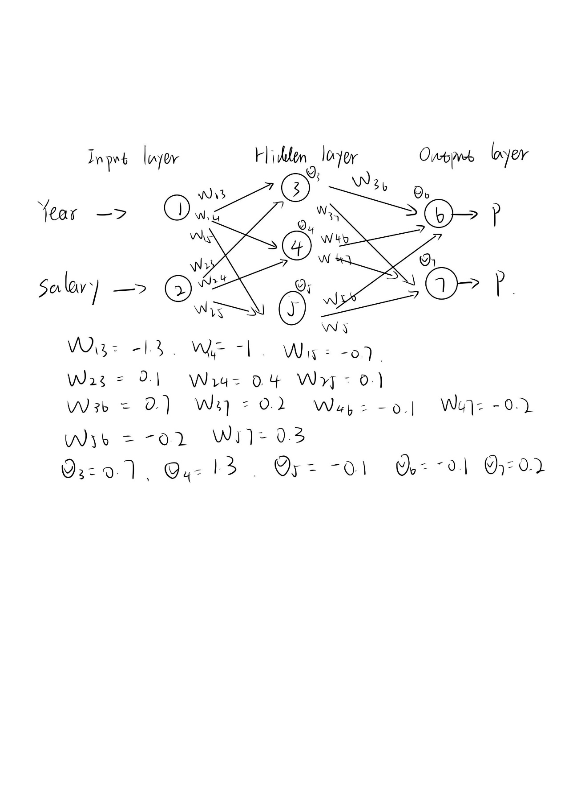

We can generate the neural network model as above. The activation function is

$$g\left(x\right)=\frac{1}{1+e^{-x}}$$

We can choose the pass like input layer-hidden layer-output layer-node 6. So, we can calculate output of each node:

Output 3 = 1/(1+exp(-(0.7-1.3*4+0.1*43))) = 0.45

Output 4 = 1/(1+exp(-(1.3-1*4+0.4*43))) = 0.99

Output 5 = 1/(1+exp(-(0.1-0.7*4+0.1*43))) = 0.8

Output 6 = 1/(1+exp(-(-0.1+0.7*0.45-0.1*0.99-0.2*0.8))) = 0.48

So the output of this pass is 0.48.